Product Description

Sugarcane Production Monitoring and Farmer Assistance System for Sugar Regulatory Administration is a system aids the board members and MDO to monitor production of sugarcane from farm level to nationwide. It also assists the Mill district officer in providing recommendations and overall assistance to farmers faster and more effectively. The system’s user are the board members, mill district officer and the farmers.

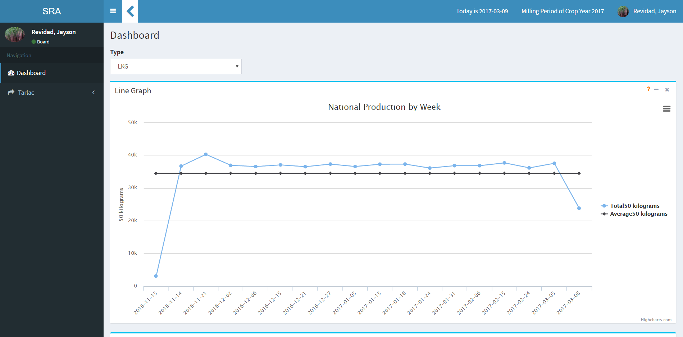

Figure 1.0 Board Dashboard

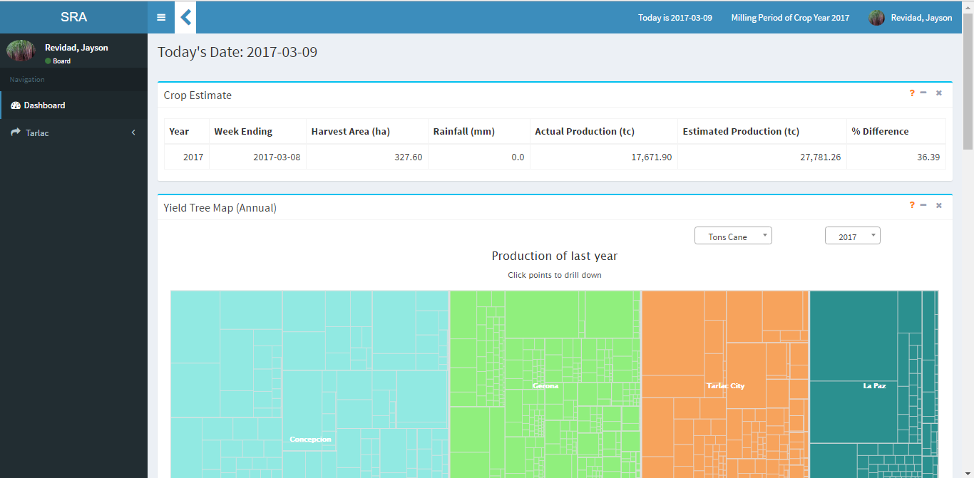

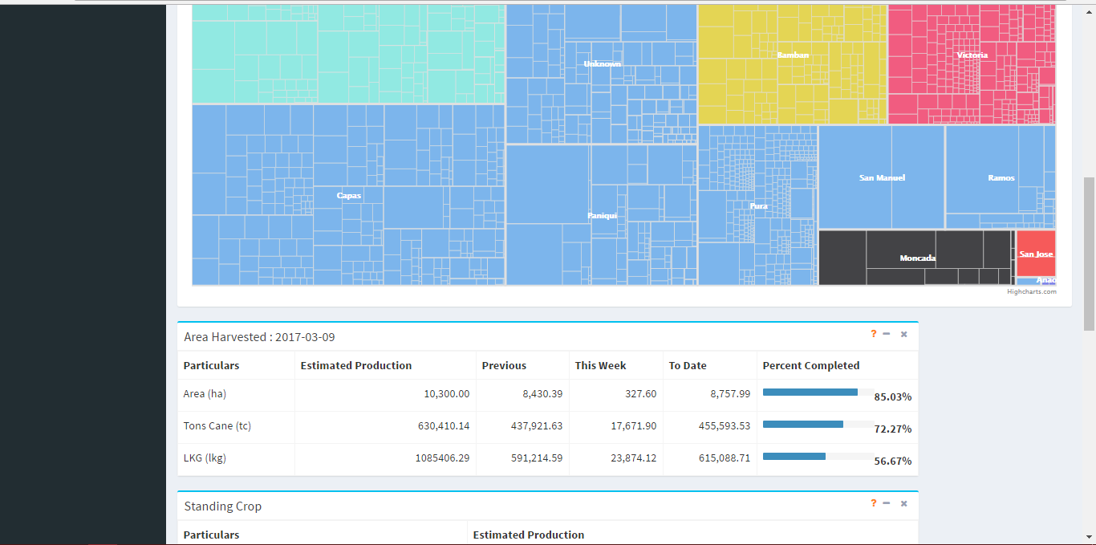

Figure 2.0 Mill District Officer Dashboard

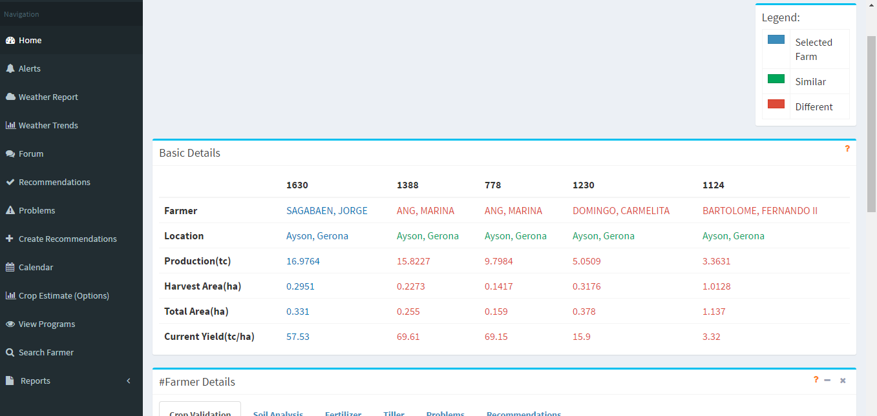

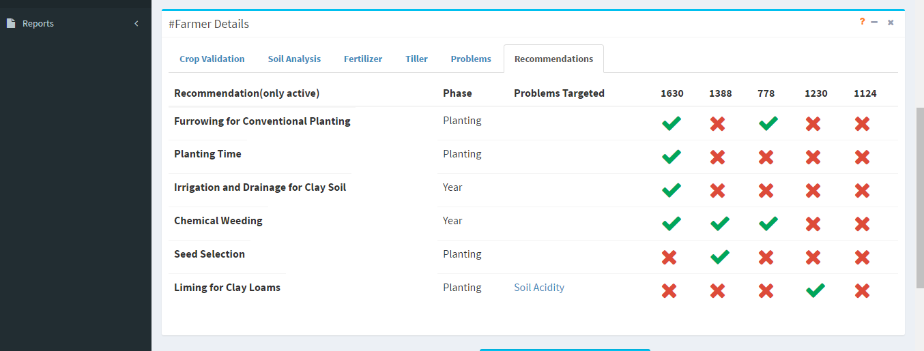

Figure 3.0 Farmer Comparison

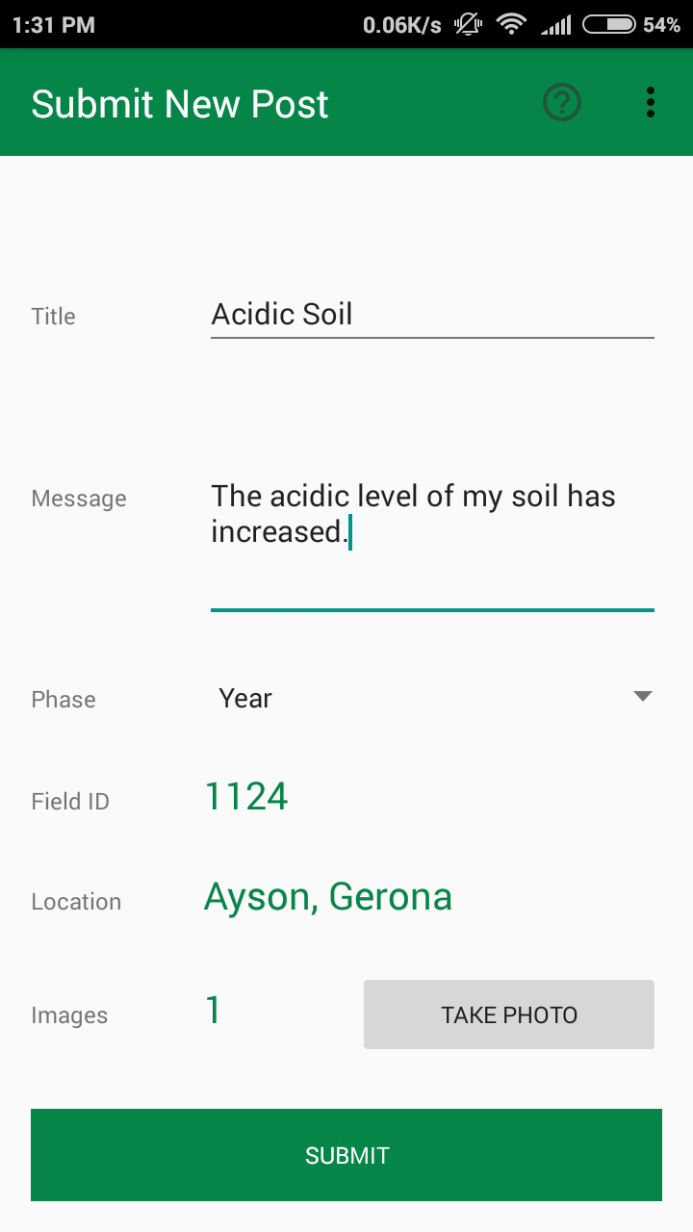

Figure 4.0 Submit Post

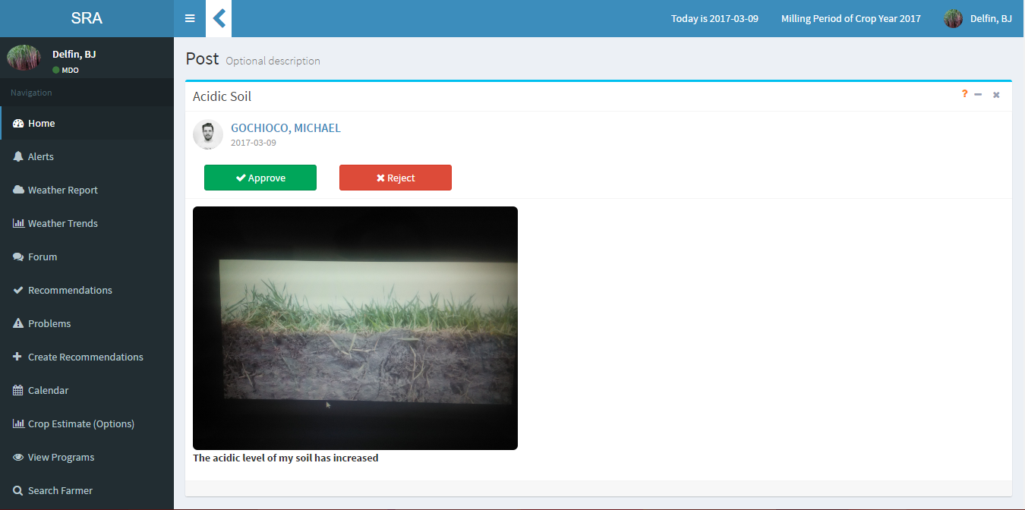

Figure 5.0 Forum

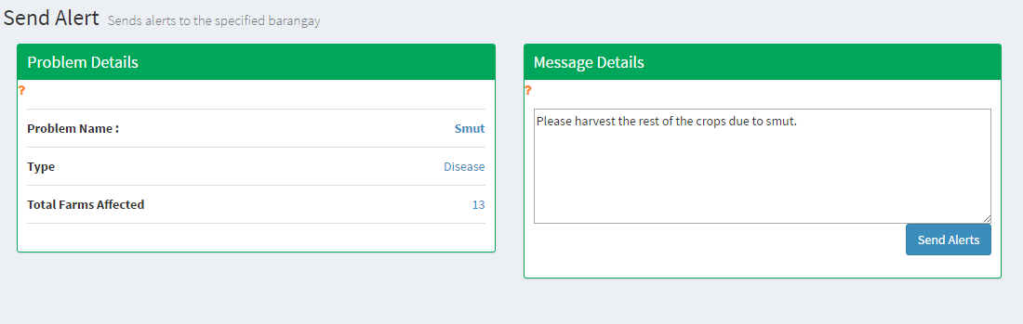

Figure 6.0 Send Alerts